###########################################################################

# THE ORD DATASET #

# Yingna Su, Yigong Zhang, Joze M. Alvarez, Hui Kong # # Mobile Robot Lab #

# Nanjing University of Science and Technology #

# https://suyingna.wixsite.com/vproad #

###########################################################################

The color images (1643 images) contained in the ORD dataset are part of the [Oxford Robotcar](http://robotcar-dataset.robots.ox.ac.uk/" \t "_blank) dataset[2].

For evaluation, all the images are manually labeled to generate the ground truth data, including the location of the vanishing point and the road region.

The images are randomly selected from 10 sequences of Oxford Robotcar dataset and are stored to 10 folders with the same names of the sequence files, respectively. At the same time, all the images are integrated into a single folder for the ease of use.

The data format is:

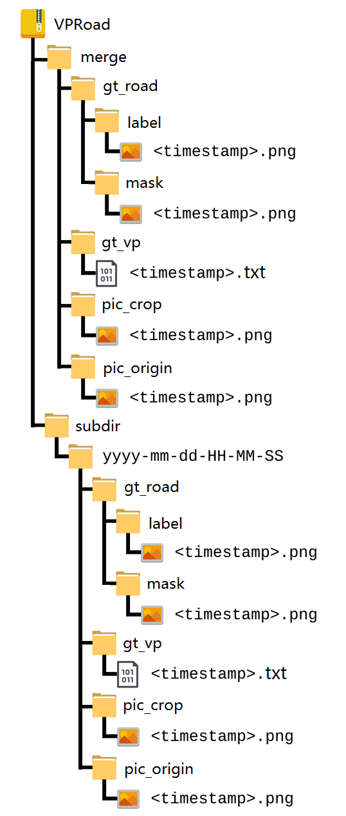

The folder named ‘merge’ stores the merged images (all 1643 images). The folder named ‘subdir’ stores the 10 sequences. The subfolder named ‘pic\_origin’ stores the original images provided by the Oxford Robotcar dataset. The subfolder named ‘pic\_crop’ stores the cropped images that the region of the vehicle’s bonnet in the bottom of the original image is cut out and then the image is normalized to the same size of 221×427. The MATLAB code for image cropping is as follows:

CropImg=imresize(OriginalImg,[320,427]);

CropImg = CropImg(40:260,:,:);

The subfolder named ‘gt\_road’ stores the ground truth of the road region of the cropped images including two subfolders named ’label’ and ‘mask’. The subfolder named ‘label’ stores labelled images where the road regions are marked red. The subfolder named ‘mask’ stores binary images where 1 represents the pixel belonging to road regions, 0 otherwise. The subfolder named ‘gt\_vp’ stores the ground truth of the location of the vanishing point. The ground truth data are provided as TXT files. Each file stores two numbers. The first and the second number are the vertical and horizontal coordinates of the vanishing point, respectively.

Please cite these papers when the ORD dataset is used:

[1] Y. Su, Y. Zhang, J. M. Alvarez, and H. Kong. "An Illumination-invariant Nonparametric Model for Urban Road Detection Using Monocular Camera and Single-line Lidar", The IEEE International Conference on Robotics and Biomimetics (ROBIO), 2017.

[2] W. Maddern, G. Pascoe, C. Linegar and P. Newman, "1 Year, 1000km: The Oxford RobotCar Dataset", The International Journal of Robotics Research (IJRR), 2016.

For any questions, please contact Yingna Su (suyingna@njust.edu.cn).